LOCI AND CONSTRUCTION
OCR GSCE – Tuesday 3 November 2020 – Paper 4 (Calculator) Higher Tier
1.
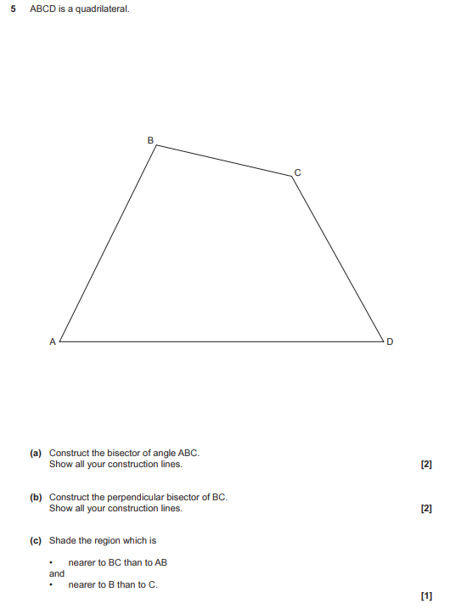

OCR GSCE – Tuesday 11 June 2019 – Paper 6 (Calculator) Higher Tier
2.
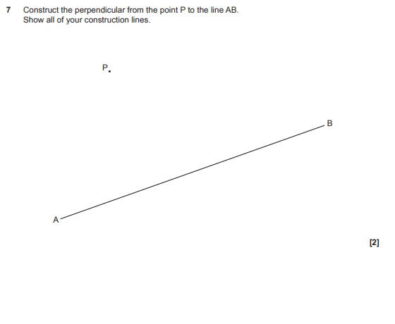
OCR GSCE – Tuesday 6 November 2018 – Paper 4 (Calculator) Higher Tier
3.
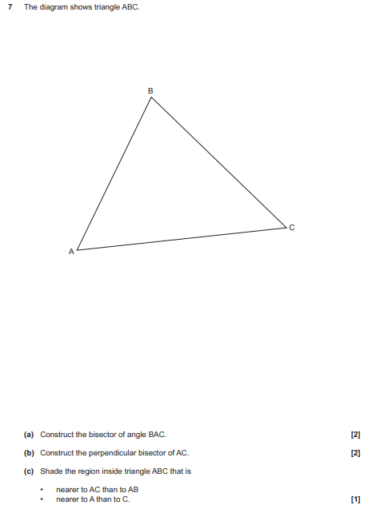

OCR GSCE – Tuesday 2 November 2017 – Paper 4 (Calculator) Higher Tier
4.
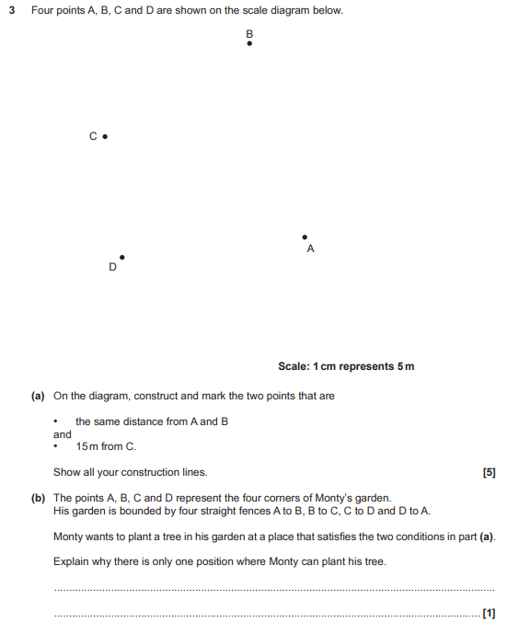

AQA GSCE – Thursday 8 June 2020 – Paper 3 (Calculator) Higher Tier
5.
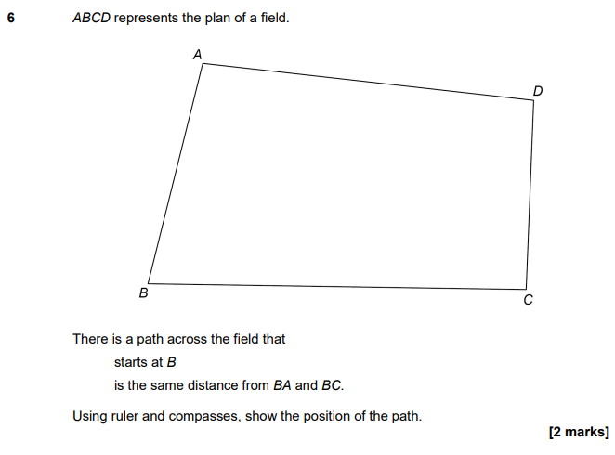

AQA GSCE – Thursday 6 June 2019 – Paper 2 (Calculator) Higher Tier
6.

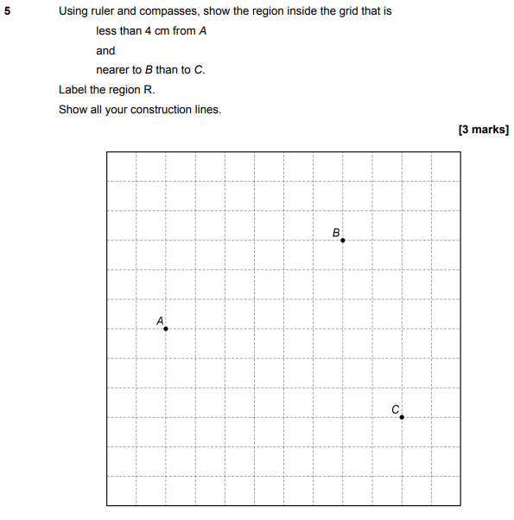

AQA GSCE – Wednesday 8 November 2017 – Paper 3 (Calculator) Higher Tier
7.
